# Ultrasonic Sensor

An ultrasonic sensor is an electronic device that measures distance by using ultrasonic sound waves. The HC-SR04 is a commonly used ultrasonic sensor in Arduino projects.

**Working Principle:**It emits an ultrasonic pulse at 40kHz which reflects off an object and returns to the sensor. The time taken for the echo to return is used to calculate the distance to the object using the speed of sound.

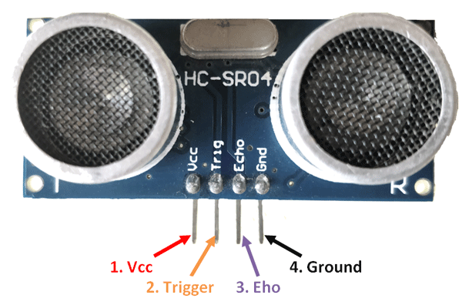**Types**:  
- HC-SR04 (common module)  
- Waterproof Ultrasonic Sensors  
- Industrial-grade sensors

**Applications**:  
- Obstacle avoidance in robots   
- Parking sensors  
- Liquid level detection  
- Object counting

**Advantages**:  
- High accuracy  
- Non-contact measurement  
- Inexpensive and easy to use with microcontrollers

**Disadvantages**: Fig : HC- SR04  
- Affected by soft or absorbent materials  
- Limited range (usually up to 4 meters)  
- Performance affected by temperature and humidity